Day 58: Implementation of 1024:1 MUX Using 8:1 MUX

Introduction: A 1024:1 Multiplexer selects one input from 1024 data inputs using 10 select lines. It can be implemented using multiple 8:1 multiplexers.

Design
- Inputs: 1024 data inputs (I[1023:0])
- Select lines: 10 (S[9:0])
- Output: 1 bit (Y)
- Basic component: 8:1 MUX

Working Principle: The 1024:1 MUX can be constructed using 8:1 multiplexers arranged in multiple stages.
- Stage 1: 128 MUXes
- Stage 2: 16 MUXes
- Stage 3: 2 MUXes
- Final stage: 1 MUX to select between the remaining two outputs
A total of 147 multiplexers are required, using 8:1 MUXes for the first three stages and a 2:1 MUX for the final stage.
The select lines control which input reaches the final output.
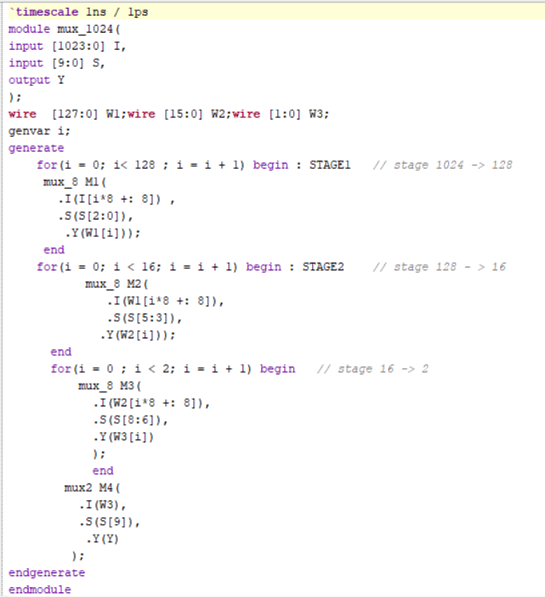

Testbench: A testbench is used to apply different input patterns and select-line combinations to verify the output.

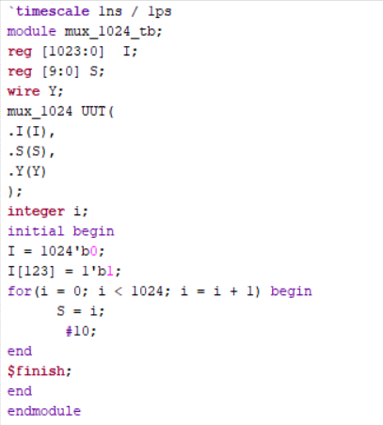

Waveform: The simulation waveform verifies that the output Y follows the input selected by the select lines.

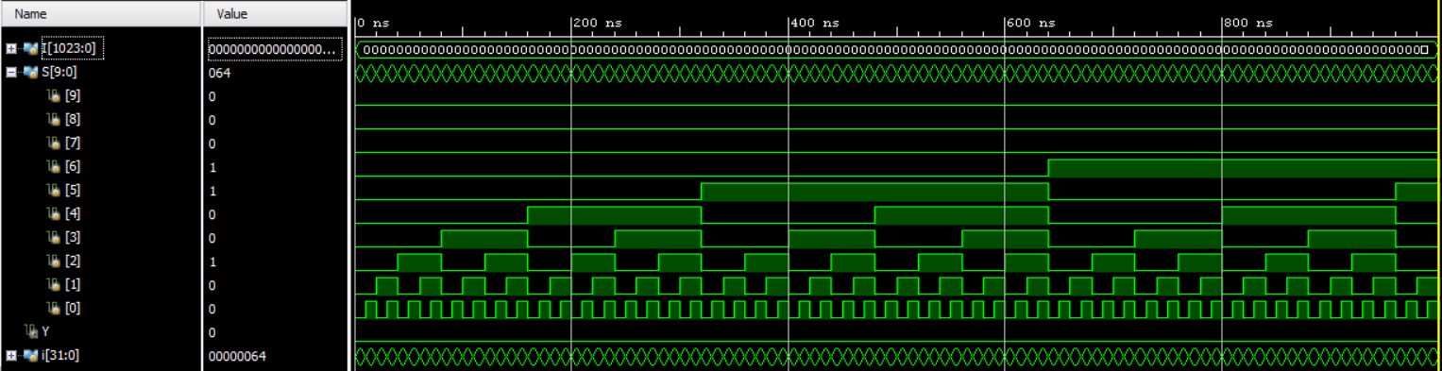

Schematic: The RTL schematic shows the hierarchical arrangement of the multiplexers connected in multiple stages.

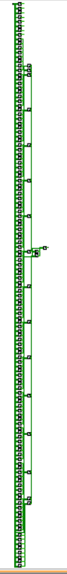

Observation The 1024:1 MUX selects one of 1024 input signals using 10 select lines. The design demonstrates how a higher-order multiplexer can be constructed using lower-order multiplexers.

#PHANEENDRA.SINGUDASU

